*in conjunction with *

*presents*



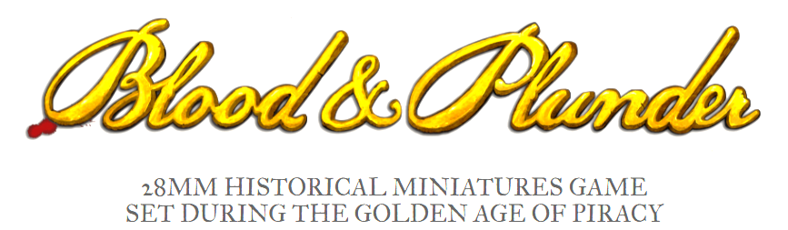

***Welcome to The PlunderDome!***

Yure chance to Raise the Black, to make as many “Arrrrrgh!” sounds as Ye can,

To swash Yure buckles, & to lead a band of 17th / 18th Century Adventurers & Rogues

Out on to the Spanish Main.

There to perform acts of daring – do as Ye seek to Plunder the Spanish Empyre.

**Firelock Games ™,** in conjunction with the **Blood & Pigment** channel, presents Introduction Games of their sensational tabletop game, **Blood & Plunder ™** at **MOAB 2025**.

Should Ye dare, Ye shall lead a crafty crew of the Brethren of the Coast as they seek to redistribute a horde of Spanish treasure

– Inevitably, to Themselves –

In a skirmish game set in balmy, tropical Caribbean dreamscapes, where Mythology & History sail side by side once more.

The games are free, the Plunder plentiful, & a brave New World of Caribbean gaming adventures awaits Ye.

